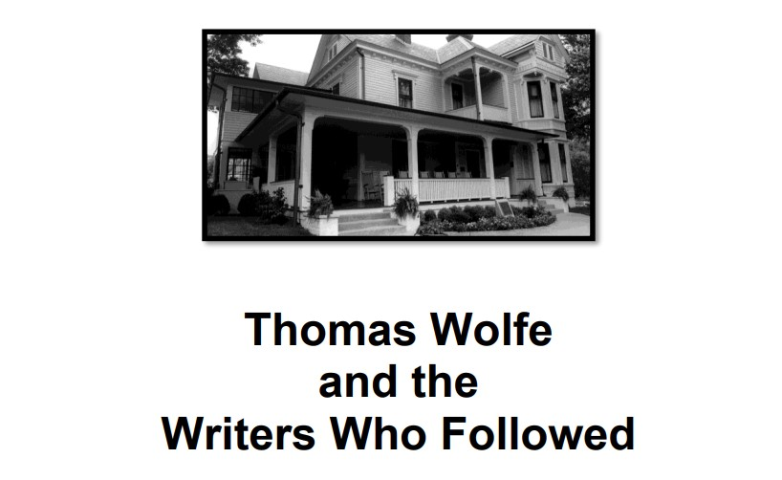

Thomas Wolfe and the Writers Who Followed: The Thomas Wolfe Society’s Forty-Second Annual Meeting Asheville, North Carolina | May 27-28, 2022

Four Points by Sheraton, Asheville

# Friday, May 27, 2022 – Morning Session

|  |  |
| --- | --- |
| 8:30-10:30 | Board of Directors Meeting |
| 11:00-12:00 | Registration |
| 12:00-12:15 | **Welcome and Prologue**  Welcome: Terry Roberts, Director, National Paideia Center; President, Thomas Wolfe Society  Prologue: Mary Aswell Doll, Savannah College of Art and Design |
| 12:15-1:00 | **Session I** (Moderator: Terry Roberts, National Paideia Center)  Welcome: Darin Waters, Deputy Secretary for Office of Archives and History, NC  Department of Natural and Cultural Resources |

**Break (1:00-1:20)**

# Friday, May 27, 2022 – Afternoon/Evening Sessions

|  |  |
| --- | --- |
| 1:20-2:20 | **Session II** (Moderator: Ruth Moose, Pittsboro, NC)  “Wolfe from the Pulpit”  Deacon Herbert Gimbel, Archdiocese of Newark, NJ  “From Commas to Cosmos: The Pervading Influence of Thomas Wolfe on Cormac McCarthy” Joshua Cody, UNC Charlotte, Charlotte, NC  “Fathers, Sons, Artistic Failures and Triumphs in Wolfe’s *Look Homeward, Angel* and Phillip Lewis’s *The Barrowfields*”  George Hovis, State University of New York Oneonta |
| 2:20-2:40 | Recognition of Charter Members  Presenter: Ray Walker, Decatur, GA  **Break (2:40 – 3:00)** |
| 3:00–3:45 | **Session III** (Moderator: Bill Turner, Arlington, VA)  “Willie Morris: A Mississippi Wolfean”  Ed Yoder, Chapel Hill, NC  “Telling It All: Thomas Wolfe and James Jones”  Sue Fields Ross, Swansboro, NC |
| 3:45–4:00 | Distinguished Service Awards  Amélie Moisy, Paris, France  Arnold Wengrow, Asheville, NC  Presenter: J. Todd Bailey, Burnsville, NC  **Break (4:00 – 4:15)** |
| 4:15–5:00 | Aldo P. Magi Remembered  Deborah Borland, Canton, OH  David Strange, Bloomington, IN  Joanne Mauldin, Weaverville, NC  J. Todd Bailey, Burnsville, NC  **Dinner on Your Own** |
| 7:30 | “Becoming the Man…the Author: The Undergraduate Years of Thomas Wolfe”  Fred W. Kiger, Chapel Hill, NC |

# Saturday, May 28, 2022 – Morning Session

|  |  |
| --- | --- |
| 8:00-9:00 | Breakfast on the porch of the Old Kentucky Home |
| 9:00-9:45 | **Session IV** (Moderator: Margie Kashdin, Brevard, NC)  “Angels and Goddesses: Messages from the Bijou and Beyond”  Dana Reaume, Fort Benning, GA  “*The Skin Artist*: Shades of Thomas Wolfe in the New South”  Paula Gallant Eckard, University of North Carolina at Charlotte |
| 9:45-10:00 | Citation of Merit  Janice McCullagh, Boulder, CO  Joanne Mauldin, Weaverville, NC  Presenter: Terry Roberts, Asheville, NC |
| 10:00-10:30 | Business Meeting  President Terry Roberts presiding  **Break (10:30-10:45)** |
| 10:45-11:30 | **Session V** (Moderator: Wayne Caldwell, Candler, NC)  “How Much Beauty and Genius, Herman Hesse Encounters Thomas Wolfe”  Steven B. Rogers, Washington, DC  “Painting America: The Related Obsessions of Thomas Wolfe and Edward Hopper”  Joseph Bentz, Azusa Pacific University |
| 11:45-12:00 | Final Words: Terry Roberts, President  Epilogue: Jan Hensley, Greensboro, NC  **Lunch on Your Own**  Saturday, May 28, 2022 – Afternoon Session |
| 2:00-3:30 | “Literary Tour of Asheville by Trolley”  Meet in hotel lobby  Group A |
| 3:30-5:00 | “Literary Tour of Asheville by Trolley”  Meet in hotel lobby  Group B |

# May 28, 2022 – Evening Session

6:00-7:00 Cash Bar (Four Points by Sheraton Hotel)

Books by Wolfe Society Authors Available for Sale and Signing

7:00 Banquet (Four Points by Sheraton Hotel)

Awards Ceremony: President Terry Roberts

Introduction of the Speaker: Tom Muir, Historic Site Manager, Thomas Wolfe Memorial

Address: “Wilma Dykeman and the Wolfe Family” James Stokely, President, Wilma Dykeman Legacy

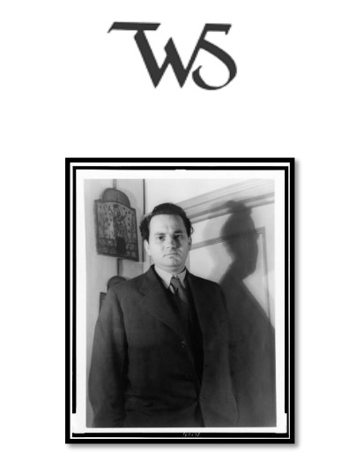

2022 Conference Committee:

Tom Muir, Terry Roberts, Lynn Roberts,

Ray Walker, and Colin Walker